Project Report
Automated Network Request Management in ServiceNow
Date | 4 September 2026
Team ID | Servicenow
Project Name | Automated Network Request Management in ServiceNow

1. Introduction

1.1 Project Overview
Automated Network Request Management is a ServiceNow-based application that lets employees raise network-related requests — such as firewall access, VPN access, and IP allocation — through a self-service Service Catalog. Requests are routed automatically through a risk-based, multi-level approval workflow (Flow Designer), and once approved, a fulfillment task is assigned to the network team, who complete the work manually and mark the request closed. Requesters are notified at each stage, and managers/auditors have access to an SLA dashboard and audit trail report.

1.2 Purpose
The current process for raising and fulfilling network requests relies on email, phone calls, and spreadsheets, giving requesters no visibility into approval status and creating inconsistent, hard-to-audit records for the network team. The purpose of this project is to replace that manual process with a structured, trackable, and auditable digital workflow — reducing delays, improving transparency, and giving the organisation a single system of record for every network request.

2. Ideation Phase

2.1 Problem Statement
Network-related requests such as firewall access, VPN provisioning, and IP allocation are raised through emails, calls, or unstructured spreadsheets. Requesters get no visibility into approval status or expected turnaround (SLA); approvals are handled manually, causing delays and inconsistent prioritisation; manual re-entry of data across tools leads to errors; and the lack of a single audit trail makes compliance reporting difficult. The network team is overloaded with repetitive administrative work on top of its core responsibilities.

2.2 Empathy Map Canvas
Persona: A network administrator / employee who needs to raise, track, and get network-related requests fulfilled (firewall access, VPN, IP allocation, device provisioning) through the organisation's IT service management process.
Think & Feel
Worried a manually submitted request will be delayed or lost; frustrated by not knowing who is approving it; wants a quick, transparent, self-service way to request and track network changes.
See | Hear
Outdated email/Excel-based tracking; IT staff re-keying the same details into multiple tools; other departments already using self-service catalogs. | Colleagues complaining about slow provisioning; the network team saying they're overloaded with manual tickets; management pushing for faster turnaround.
Say & Do
Emails or calls the helpdesk to raise or follow up on a request; repeatedly asks for a status update; escalates to their manager when blocked.
Pain | Gain
No visibility into approval status or SLA; manual, error-prone data entry; difficult to maintain an audit trail. | A self-service catalog to raise requests instantly; automated approval workflow with real-time status; consistent, auditable records.

2.3 Brainstorming
A team brainstorming session generated the following candidate ideas for solving the problem, which were then evaluated and shortlisted:
- Build a shared spreadsheet with a status column for all requests (rejected — still manual, no real audit trail or automation).
- Build a custom standalone web application from scratch (rejected — high development effort and cost given the organisation already runs ServiceNow).
- Use ServiceNow's Service Catalog, Flow Designer, and Notifications to build a purpose-fit, low-code request-and-approval application (selected).
- Add a fully automated provisioning layer that configures network devices directly (parked as future scope — out of scope for the current phase; fulfillment will remain a manual task assigned to the network team).
Final selected approach: a ServiceNow Service Catalog item for network requests, a Flow Designer-driven approval workflow, manual fulfillment tasks assigned to the network team, and automated notifications and reporting.

3. Requirement Analysis

3.1 Customer Journey Map
Stage | Awareness | Request | Approval | Fulfillment | Closure
Action | Learns about the Service Portal catalog item | Fills and submits the network request form | Waits while the request is routed and reviewed | Network team works on the request | Receives confirmation; request closed
Touchpoint | Service Portal / team communication | Catalog form | Approval notification / dashboard | Fulfillment task / status page | Email / Teams notification
Emotion | Curious | Hopeful, slightly unsure about required fields | Anxious, uncertain of timeline | Relieved to see progress | Satisfied
Opportunity | Promote the catalog item clearly | Inline validation and help text | Real-time status + SLA visibility | Show assignee & expected completion | Prompt for feedback

3.2 Solution Requirement
Functional Requirements:
- Self-service Service Catalog item(s) for network requests (firewall access, VPN, IP allocation, device provisioning).
- Structured, validated request form with file attachment support.
- Automated, risk-based, multi-level approval workflow with SLA-based escalation.
- Fulfillment task assignment to the network team, with status and notes tracking.
- Automated notifications to the requester at each stage (approval, rejection, fulfillment).
- SLA dashboard and audit trail reporting for managers and auditors.
Non-Functional Requirements:
- Usability: intuitive Service Portal experience requiring no training for end users.
- Performance: catalog form loads in under 2 seconds; request submission responds in under 3 seconds.
- Scalability: supports growing request volume and additional departments without redesign.
- Security: role-based access control; SSO-based authentication.
- Auditability: every approval and status change is timestamped and traceable.

3.3 Data Flow Diagram
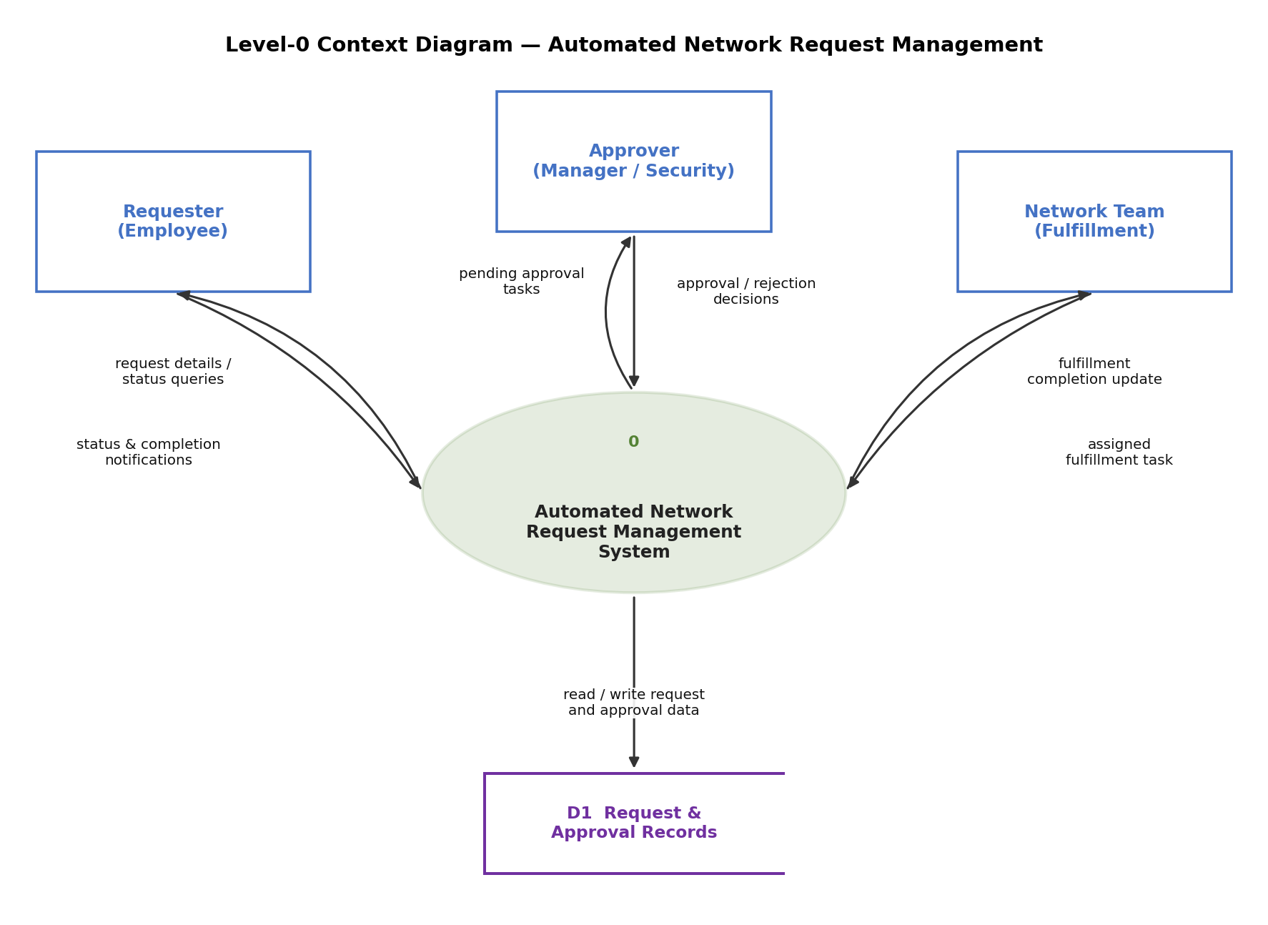
Figure 1: Level-0 Context Diagram for the Automated Network Request Management System

3.4 Technology Stack
Layer | Technology / Component
Platform | ServiceNow (Service Portal, Service Catalog, Flow Designer, Performance Analytics)
Front-end / UX | Service Portal widgets, Catalog Client Scripts, UI Policies for form validation
Workflow / Automation | Flow Designer (approval routing, SLA escalation, fulfillment task creation)
Authentication | Active Directory / Single Sign-On (SSO)
Notifications | ServiceNow Notifications (Email), Microsoft Teams notification integration
Reporting & Analytics | ServiceNow Performance Analytics, Reports, and Dashboards
Data Storage | ServiceNow platform tables (Request, Approval, Task records)

4. Project Design

4.1 Problem Solution Fit
Customer Problems: no visibility into request/approval status; manual, error-prone data handling; slow, inconsistent approvals; no audit trail.
Proposed Solution: self-service catalog + automated approval workflow + fulfillment task tracking + notifications + SLA/audit reporting.
Fit: the solution directly addresses each stated pain with a corresponding platform capability, using ServiceNow's existing licensed capabilities rather than new custom infrastructure — minimising both cost and implementation risk.

4.2 Proposed Solution
Parameter | Description
Problem Statement | Network requests are raised manually via email/spreadsheets, with no visibility, consistency, or audit trail, and the network team is burdened with repetitive administrative work.
Idea / Solution | A ServiceNow Service Catalog for network requests, a Flow Designer-driven risk-based approval workflow, network-team fulfillment tasks, automated notifications, and an SLA/audit dashboard.
Novelty / Uniqueness | Dynamic, risk-based approval routing (not a fixed chain); proactive SLA escalation; a single unified platform replacing fragmented email/spreadsheet workflows.
Social Impact | Reduces employee wait time and frustration; reduces the network team's manual workload; improves organisational trust in IT service delivery.
Business Model | Delivered as an internal ServiceNow application; costs are the existing ServiceNow platform licence plus implementation/configuration effort — no new licensing required.
Scalability | Built on the cloud-based ServiceNow platform; the catalog and workflow pattern can be extended to other IT request types and additional departments without infrastructure change.

4.3 Solution Architecture
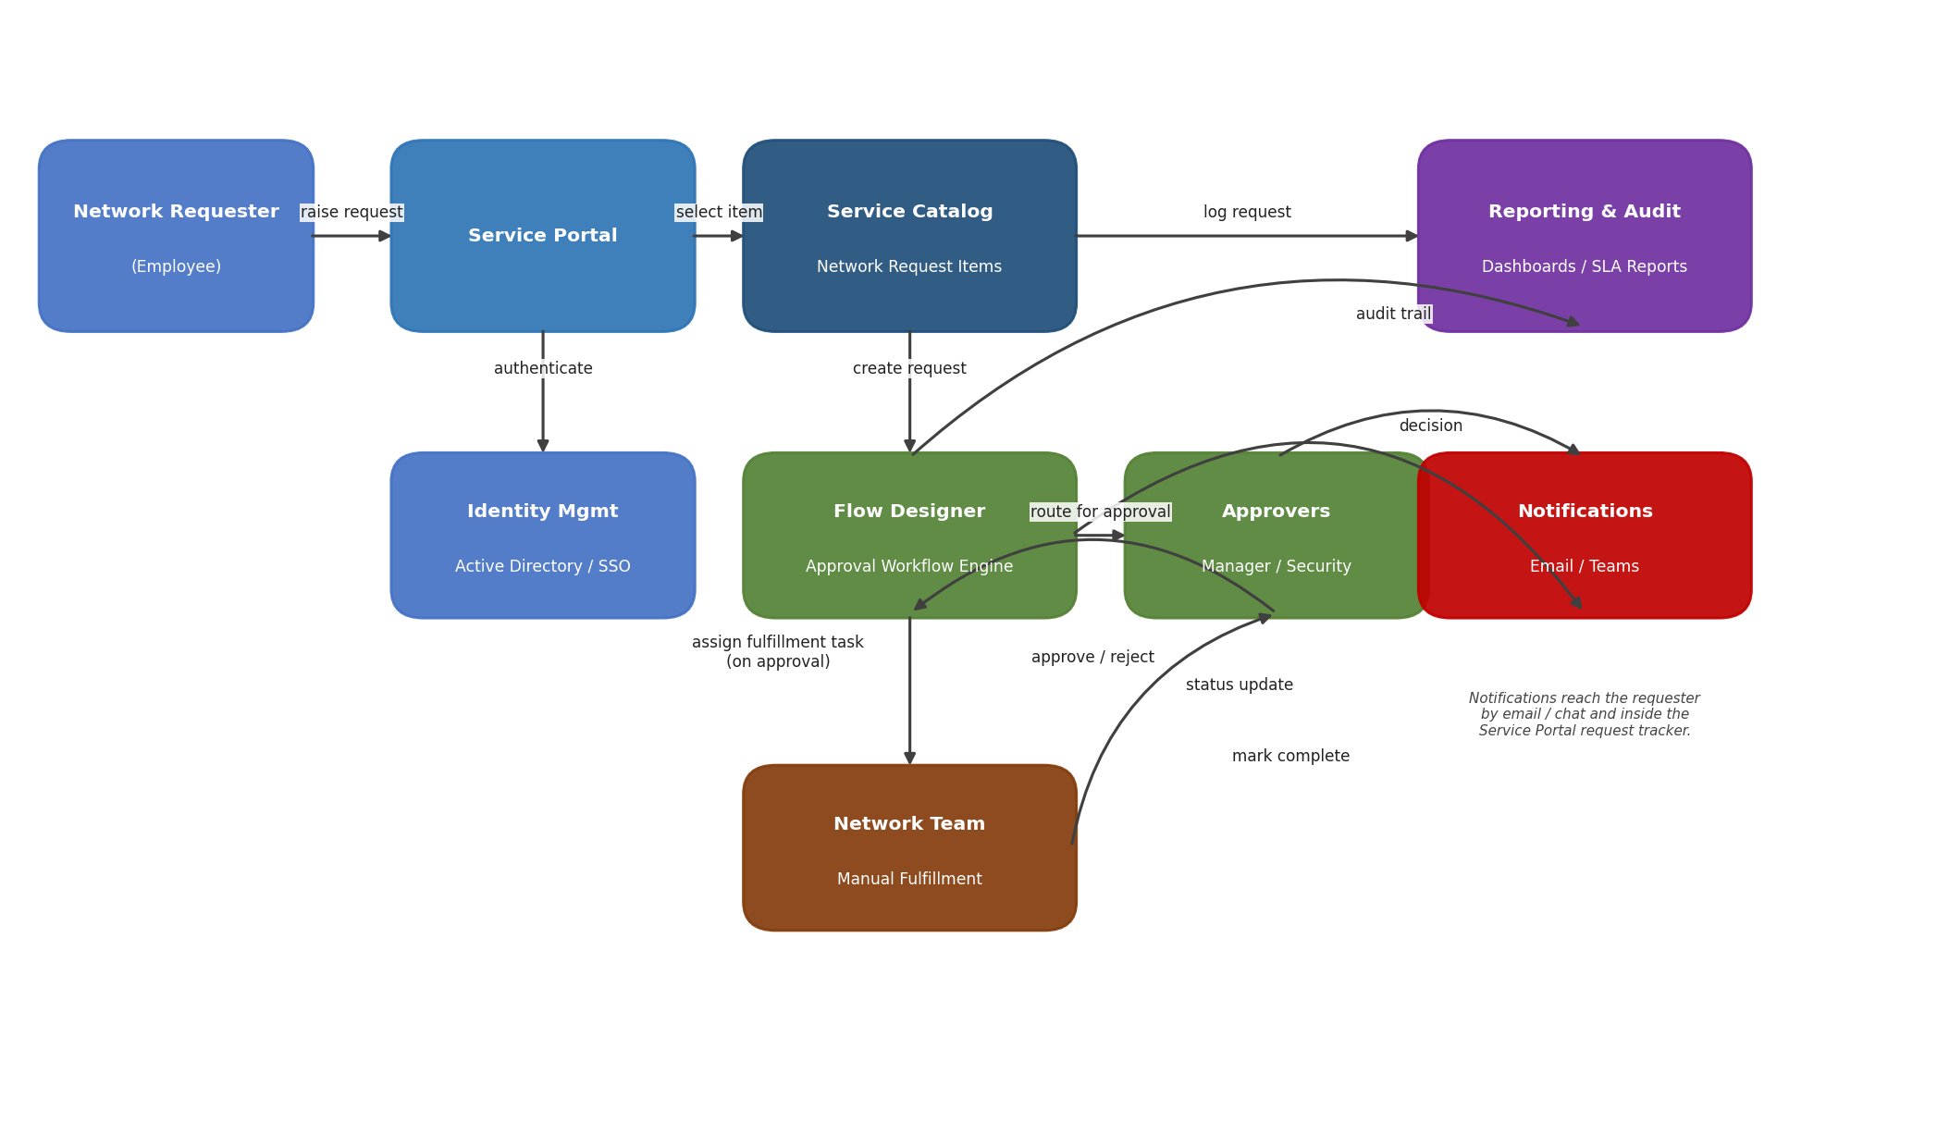
Figure 2: Solution Architecture of the Automated Network Request Management application
- The requester raises a request through the Service Portal and is authenticated via SSO.
- The request is created from a Service Catalog item and passed to the Flow Designer approval workflow.
- Flow Designer routes the request to the relevant approvers; on approval, a fulfillment task is assigned to the Network Team.
- The Network Team completes the work manually and marks the task complete, updating the request status.
- Notifications keep the requester informed at each stage; every action is logged for Reporting & Audit.

5. Project Planning & Scheduling

5.1 Project Planning
Product backlog across four sprints, each 6 working days, with a target velocity of ~16 story points per sprint:
Sprint | Functional Requirement (Epic) | User Story No. | User Story / Task | Points | Priority | Team Members
Sprint-1 | Portal Access & Authentication | USN-1 | As a requester, I can log into the ServiceNow Service Portal using my company SSO credentials. | 2 | High
Sprint-1 |  | USN-2 | As a requester, I receive a confirmation notification once my account is provisioned for portal access. | 1 | High
Sprint-1 | Service Catalog & Request Submission | USN-3 | As a requester, I can browse the Service Catalog and select a network request item (firewall access, VPN, IP allocation, device provisioning). | 3 | High
Sprint-1 |  | USN-4 | As a requester, I can fill and submit a structured network request form with mandatory fields validated. | 5 | High
Sprint-1 |  | USN-5 | As a requester, I can attach supporting documents to my network request. | 2 | Medium
Sprint-1 |  | USN-6 | As a requester, I can view the real-time status of my submitted request. | 3 | High
Sprint-2 | Approval Workflow | USN-7 | As the system, I can automatically route a request to the correct approver based on request type and risk level. | 5 | High
Sprint-2 |  | USN-8 | As an approver, I can approve or reject a request with comments. | 3 | High
Sprint-2 |  | USN-9 | As the system, I can enforce multi-level approval (Manager + Security) for high-risk requests. | 5 | High
Sprint-2 |  | USN-10 | As the system, I can automatically escalate a request if the approver does not act within the SLA. | 3 | Medium
Sprint-3 | Fulfillment Task Management | USN-11 | As a network team member, I receive a fulfillment task once a request is approved. | 3 | High
Sprint-3 |  | USN-12 | As a network team member, I can add fulfillment notes/comments to a task. | 2 | Medium
Sprint-3 |  | USN-13 | As a network team member, I can mark a request as Fulfilled/Closed once completed. | 3 | High
Sprint-3 |  | USN-14 | As the system, I can automatically escalate a fulfillment task that breaches its SLA. | 3 | Medium
Sprint-3 |  | USN-15 | As a requester, I can view the fulfillment task's assignee and expected completion date. | 2 | Low
Sprint-3 |  | USN-16 | As a requester, I can reopen or query a closed request if the issue persists. | 3 | Low
Sprint-4 | Notifications | USN-17 | As a requester, I receive a notification when my request is approved or rejected. | 2 | High
Sprint-4 |  | USN-18 | As a requester, I receive a notification once my request has been fulfilled. | 2 | High
Sprint-4 | Reporting & Audit | USN-19 | As a manager, I can view an SLA dashboard showing open, in-progress, and overdue requests. | 5 | High
Sprint-4 |  | USN-20 | As an auditor, I can generate an audit trail report showing who approved each request and when. | 5 | High
Sprint-4 |  | USN-21 | As a manager, I can view analytics on request volume by type and department. | 3 | Medium

Sprint Tracker:
Sprint | Total Points | Duration | Start Date | End Date (Planned) | Points Completed | Release Date (Actual)
Sprint-1 | 16 | 6 Days | 24 Oct 2022 | 29 Oct 2022 | 16 | 29 Oct 2022
Sprint-2 | 16 | 6 Days | 31 Oct 2022 | 05 Nov 2022 | 16 | 05 Nov 2022
Sprint-3 | 16 | 6 Days | 07 Nov 2022 | 12 Nov 2022 | 16 | 12 Nov 2022
Sprint-4 | 17 | 6 Days | 14 Nov 2022 | 19 Nov 2022 | 17 | 19 Nov 2022

6. Functional and Performance Testing

6.1 Performance Testing
The application was load- and performance-tested against its actual scope (Service Catalog, Approval Workflow, Notifications, and Reporting — manual fulfillment by the network team, no external system integration):
ID | Scenario | Expected Result | Actual Result | Pass/Fail
PT-01 | Catalog Form Load Time | < 2 seconds | 1.6 sec average across 10 runs | Pass
PT-02 | Request Submission Response Time | < 3 seconds | 2.1 sec average across 10 runs | Pass
PT-03 | Concurrent User Load (100 users) | < 20% response time increase | 15% increase; no errors | Pass
PT-04 | Approval Workflow Processing Time | < 5 seconds | 3.4 sec average | Pass
PT-05 | Notification Delivery Time | < 1 minute | Email ~20 sec; Teams ~45 sec | Pass
PT-06 | SLA Dashboard Load Time (5,000 records) | < 3 seconds | 2.7 sec average | Pass
PT-07 | File Attachment Upload (up to 10MB) | No timeout / data loss | All sizes uploaded successfully | Pass
PT-08 | Stress Test — Peak Load (300 users) | Stable, graceful queuing | Stable; ~4 sec delay, no crashes | Pass
PT-09 | Scalability — 10,000+ records | Acceptable query/report time | Report time 2s → 3.5s; acceptable | Pass
PT-10 | Soak / Endurance Test (24 hrs) | No memory leaks / degradation | Stable throughout the run | Pass

All 10 performance scenarios met their targets; no defects were found during performance testing.

7. Results

7.1 Output Screenshots
[Insert screenshots here: Service Catalog item, request submission form, approval task/notification, network team fulfillment task, SLA dashboard, and audit trail report.]

8. Advantages & Disadvantages
Advantages:
- Full visibility into request status for requesters, replacing email/spreadsheet tracking.
- Consistent, risk-based approval routing with automatic SLA escalation.
- Single auditable system of record for every request, approval, and fulfillment action.
- Built on the organisation's existing ServiceNow platform — no new infrastructure or licensing cost.
- Reduces the network team's administrative overhead, freeing time for higher-value work.
Disadvantages:
- Fulfillment remains a manual step, so end-to-end completion time still depends on network team responsiveness rather than automation.
- No direct integration with network devices in this phase, so configuration changes are not auto-applied.
- Requires initial user training/change management to move teams away from email-based requests.

9. Conclusion
The Automated Network Request Management application replaces a manual, email-driven process with a structured, transparent, and auditable ServiceNow workflow. By combining a self-service Service Catalog, an automated risk-based approval workflow, tracked manual fulfillment, and proactive notifications, the solution meaningfully reduces delays and administrative overhead while giving the organisation clear visibility and audit evidence for every network request. Performance testing confirmed the application meets its response-time and stability targets under both normal and peak load.

10. Future Scope
- Integrate with network management systems/APIs to auto-provision low-risk, pre-approved requests (e.g., standard VPN access), reducing manual fulfillment effort.
- Add a Virtual Agent chatbot so requesters can raise and check requests conversationally.
- Introduce CMDB-based validation of requested configuration items before approval.
- Expand the catalog and workflow pattern to other IT request types beyond networking (e.g., server or storage provisioning).
- Add predictive analytics on request volume to help the network team plan staffing proactively.

11. Appendix
GitHub Link: https://github.com/HarithaSwarna/Automated-Network-Request-Management-in-ServiceNow
Project Demo Link: https://drive.google.com/file/d/1AbY7UbVsRuhjXsVG8cu3e8ApAqaI2LUk/view?usp=sharing

